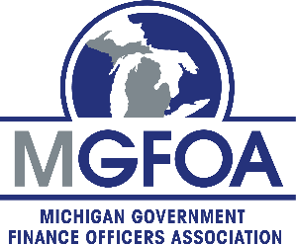
NEWS RELEASE
Contact:
Michigan Government Finance Officers Association (MGFOA)
Bob Hertel, Executive Director
231-947-0882
Executive@MiGFOA.org

Release Date: October 12, 2021

MGFOA Elects New Board of Directors

Traverse City, Michigan – Today the Michigan Government Finance Officers would like to welcome its 2021-2022 Board of Directors.
Immediate Past President – Gretchen Gomolka, Finance Director at City of Brighton, Michigan
President - Heidi Scheppe, Treasurer at Grand Traverse County, Michigan
Vice President – Ginger Burke-Miller, Finance Director/Treasurer at City of Dearborn, Michigan
Treasurer – Jody Weissler DeFoe, Chief Deputy Treasurer at Oakland County, Michigan
Director – Chrystal Simpson, Chief Finance Officer, Genesee County, Michigan
Director – Sheryl Johnson, Chief Central Fiscal Services, Oakland County, Michigan
Director – Adam Bonarek, Finance, Risk and IT Director at Charter Township of Redford, Michigan
Director – Hughey Newsome, Chief Financial Officer at Wayne County, Michigan
Associate Director – Bill Brickey, Partner at Plante & Moran, PLLC
Associate Director – Ali Barnes, Principal at Yeo & Yeo CPAs
Associate Director – Nathaniel Watson, Senior Managing Consultant at Public Finance Management

The board was unanimously elected by the membership in attendance at the Association’s membership lunch meeting on Tuesday, October 5, 2021.

Michigan Government Finance Officers Association is a professional association of public officials and finance professionals, established in 1938, striving to promote excellence in government finance. Public sector members are practitioners in all areas of finance in state and local government. Associate members are CPAs, bankers, brokers, consultants, lawyers, educators and others concerned with local government finance. The organization averages in excess of 600 members representing nearly five hundred communities.
###

